
Eynesbury C of E Primary School – Calculations Guidance
(Addition)

When should I use this guidance?
This guidance will support your teaching of specific addition and subtraction units and any other units where pupils are required to add or subtract. It will also support you across the year in the teaching of mental calculations.
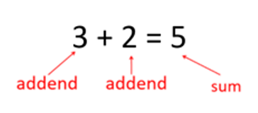
Language to use:

Aggregation: Combining two or more parts to make a whole is called aggregation.
Augmentation: This is when you increase a quantity by another quantity eg first there were 5 rabbits, then another 3 came along so now there are 8.
Commutative: Addition is commutative because the parts can be added in any order.

For additional information:
If you require more information on the use of any resources please refer to the White Rose Calculation Guidance which can be found here:
https://assets.whiterosemaths.com/new-schemes/wrm-addition-subtraction-calculation-policy-july-2022.pdf

FOR ANY CALCULATION THAT IS WRITTEN DOWN:
We need to encourage pupils to stop and think, which is the most efficient method for solving this. Make sure they look at the numbers involved. Ensure we spend time discussing the quickest, most efficient way to solve this before asking children to find the answer. We want our pupils to be calculating not counting. Just because the calculation is written, it doesn’t mean a written calculation is needed to solve it.

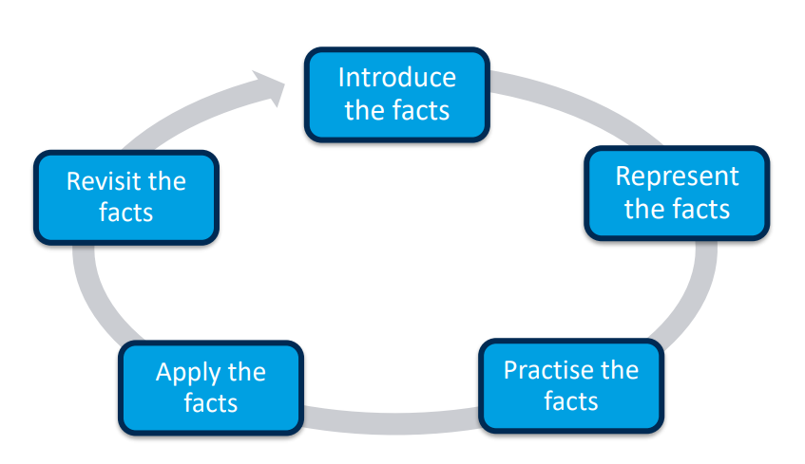
Progression in Mental Calculation Strategies: When learning key facts:
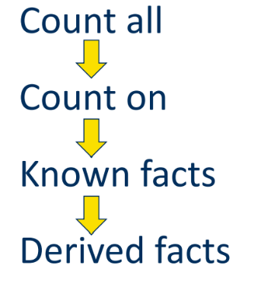

Please ensure that you look at the year groups that have gone before your and recap if needed or use the progression to differentiate for pupils with SEND.
KEY POINT: We currently use White Rose as a scheme to guide us, but you must make the scheme your own, adjust it as you need to, add in additional models and images as suggested here. Take more time to support pupils in developing efficient mental calculations. (Use Teaching Children to Calculate Mentally 2010 for ideas/support.)
MAKE SURE YOU VARY THE LOCATION OF THE = IN CALCULATIONS ie 24 = 10 + 14 as well as 10 + 14 = 24
YEAR 1

Key Resources to use: part whole models, bar models, cubes, numicon, number lines, number tracks, tens frames, arrow cards, money, rekenreks, bead bars, everyday items, counters, diennes,
For all models and images ensure pupils get used to seeing them in any orientation.

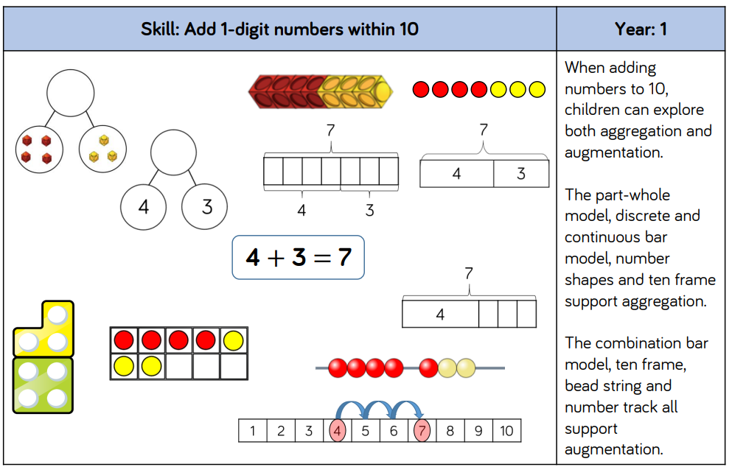
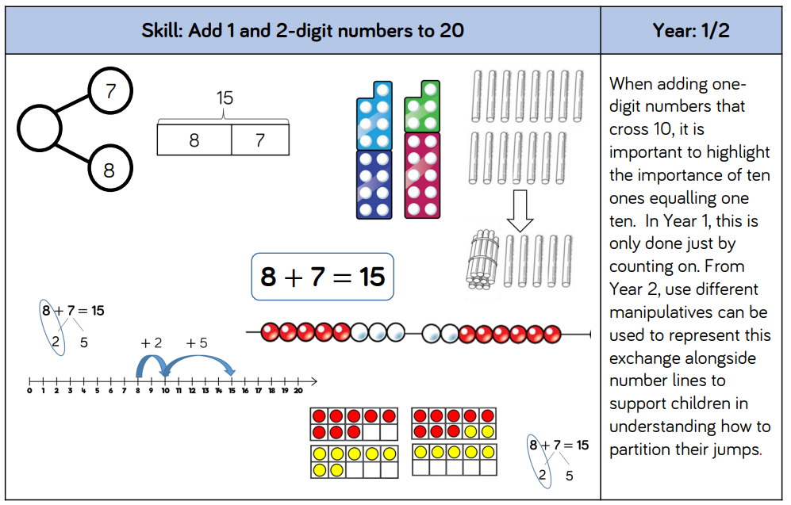

YEAR 2

Key Resources to use: part whole models, bar models, cubes, numicon, number lines, number tracks, tens frames, arrow cards, money, rekenreks, bead bars, everyday items, counters, diennes, hundred squares, place value counters, place value grid
For all models and images ensure pupils get used to seeing them in any orientation.

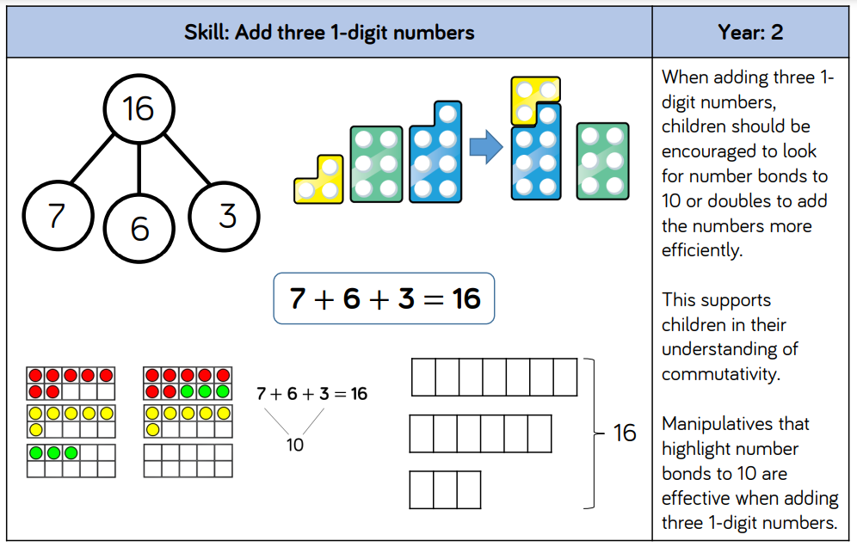
White Rose introduces column addition at this point. Pupils may have been exposed to this method from parents, therefore at Eynesbury we have chosen to teach pupils this as one method> However, we must ensure that it is not being used as a default method, preventing pupils from thinking about what they are doing. The risk is pupils learn the method and carry it out with little thought about what they are doing or why.

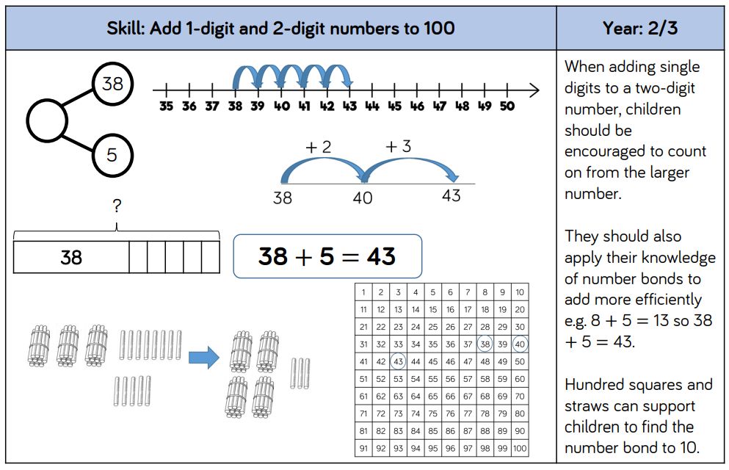
NB: When using the column method, ensure pupils are clear what each number represents. Eg 3 ones plus 7 ones is 10 ones which we can rename as 1 ten.

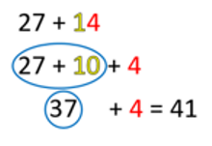
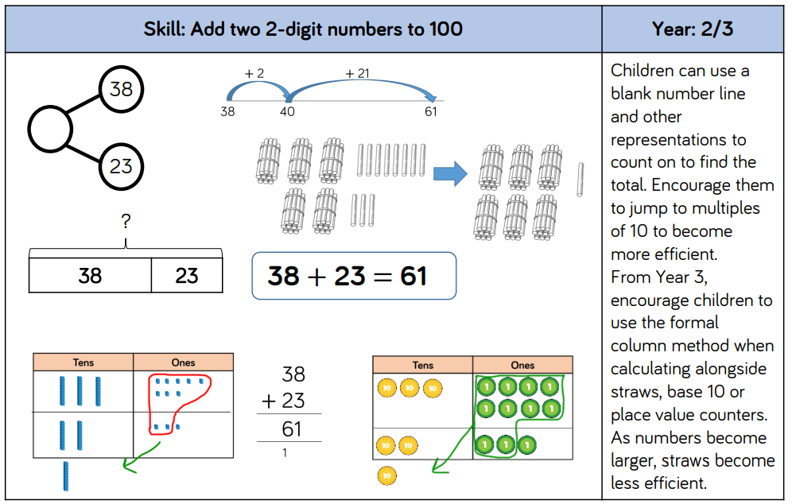

YEAR 3 and 4

Key Resources to use: part whole models, bar models, number lines, number tracks, tens frames, arrow cards, money, rekenreks, bead bars, diennes, hundred squares, place value counters, place value grid
For all models and images ensure pupils get used to seeing them in any orientation.

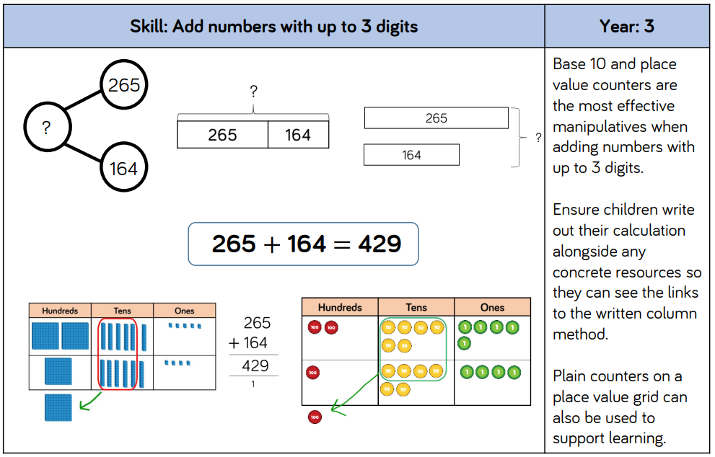
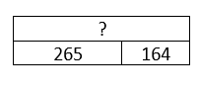
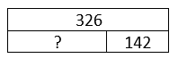
Ensure pupils are exposed to missing box problems.

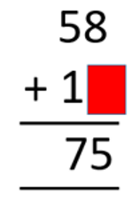

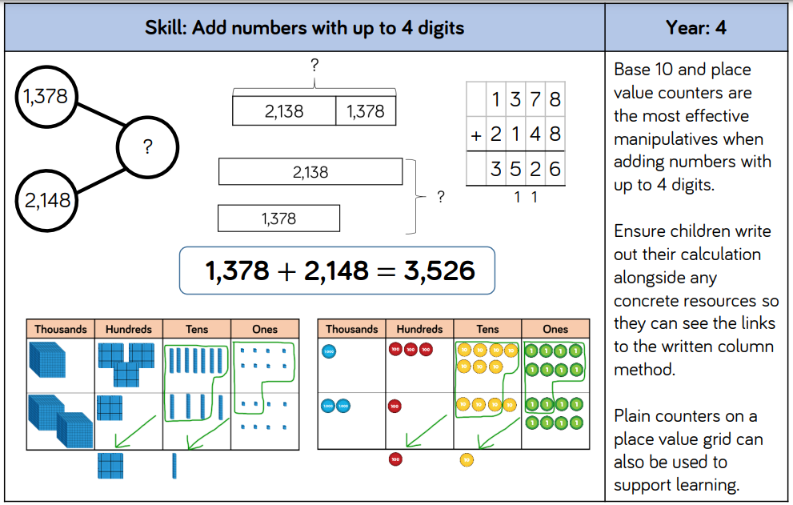

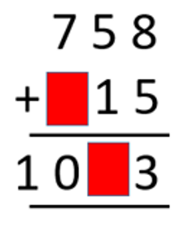

YEAR 5 and 6

Key Resources to use: part whole models, bar models, number lines, place value counters, place value grid
For all models and images ensure pupils get used to seeing them in any orientation.


