
Eynesbury C of E Primary School – Calculations Guidance
(Division)

When should I use this guidance?
This guidance will support your teaching of specific multiplication and division units and any other units where pupils are required to add or subtract. It will also support you across the year in the teaching of mental calculations.

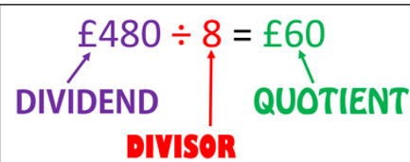
Language to use:

Division can be carried out in two ways. As grouping or as sharing. Pupils must explore both ways.

Division as grouping: eg 12 objects put into groups of 4. (You would end up with 3 groups)
Questions such as: I have 12 cookies and I put them into bags of 4. How many bags do I need?

Division as sharing: eg 12 objects shared into 4 groups (one for you, one for you style initially)
Questions such as: I have 12 cookies and I shared them between 4 people. How many do they get each?

For additional information:
If you require more information on the use of any resources please refer to the White Rose Calculation Guidance which can be found here:
https://assets.whiterosemaths.com/new-schemes/wrm-addition-subtraction-calculation-policy-july-2022.pdf
This has guidance/ideas for each timestable which staff may find useful.

FOR ANY CALCULATION THAT IS WRITTEN DOWN:
We need to encourage pupils to stop and think, which is the most efficient method for solving this. Make sure they look at the numbers involved. Ensure we spend time discussing the quickest, most efficient way to solve this before asking children to find the answer. We want our pupils to be calculating not counting. Just because the calculation is written, it doesn’t mean a written calculation is needed to solve it.

Please ensure that you look at the year groups that have gone before your and recap if needed or use the progression to differentiate for pupils with SEND.
KEY POINT: We currently use White Rose as a scheme to guide us, but you must make the scheme your own, adjust it as you need to, add in additional models and images as suggested here. Take more time to support pupils in developing efficient mental calculations. (Use Teaching Children to Calculate Mentally 2010 for ideas/support.)
MAKE SURE YOU VARY THE LOCATION OF THE = IN CALCULATIONS ie 8 = 16 ÷ 2 as well as 16 ÷ 2 =8

YEARS 1 AND 2

Key Resources to use: part whole models (when looking at repeated addition), bar models, cubes, numicon, number lines, tens frames, money, rekenreks, bead bars, everyday items, counters, diennes, place value counters, place value grid, counting stick
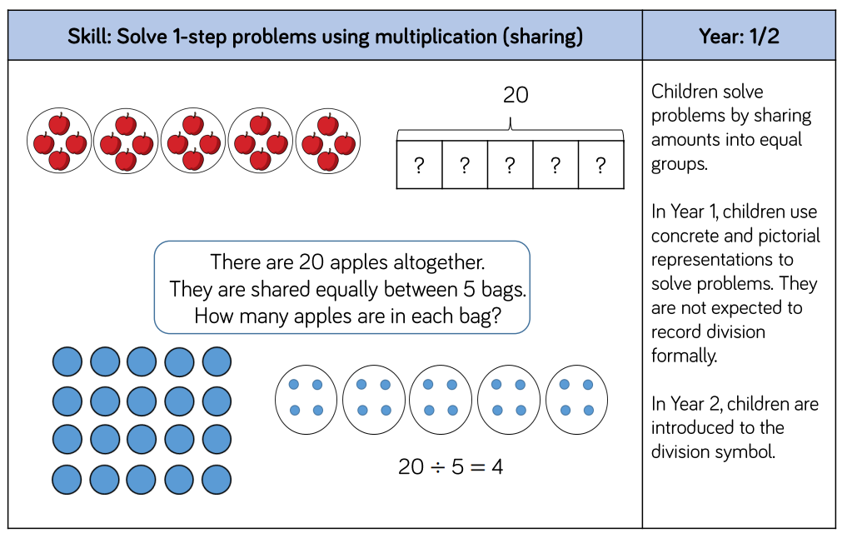

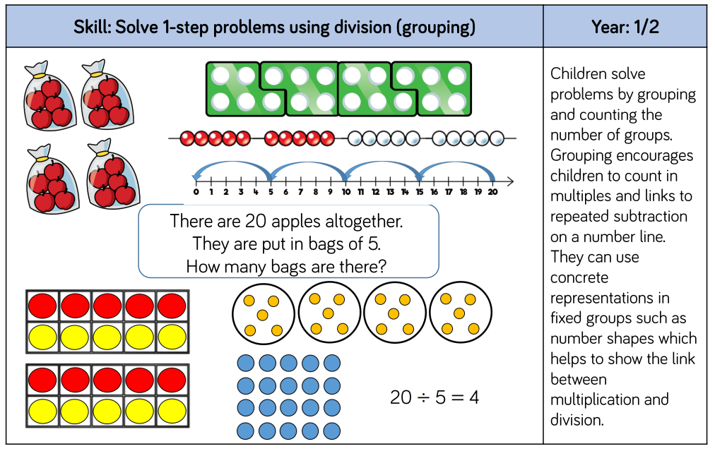

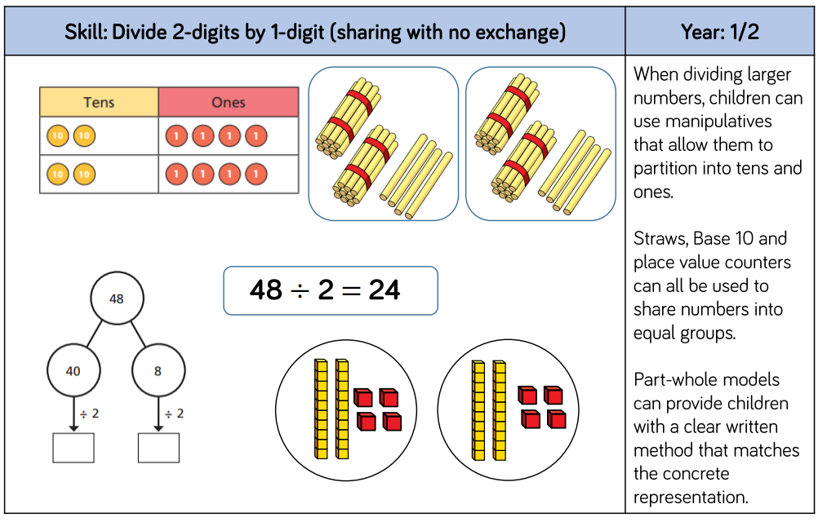

YEARS 3 AND 4

Key Resources to use: bar models, cubes, numicon, number lines, money, counters, diennes, place value counters, place value grid, counting stick,

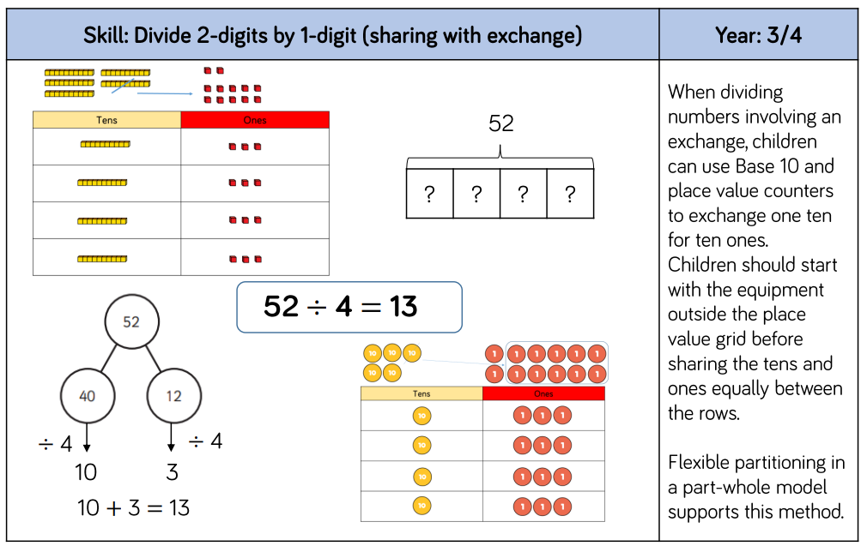

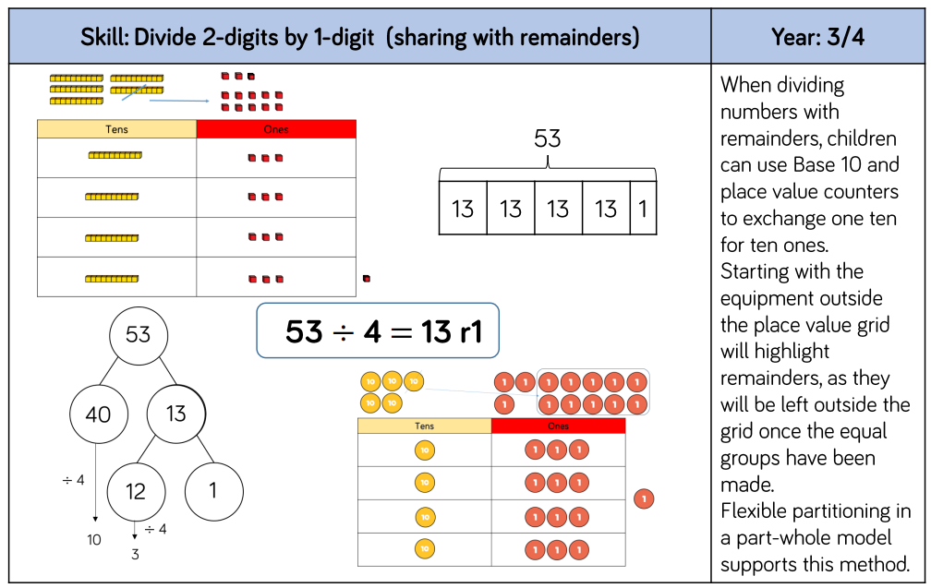

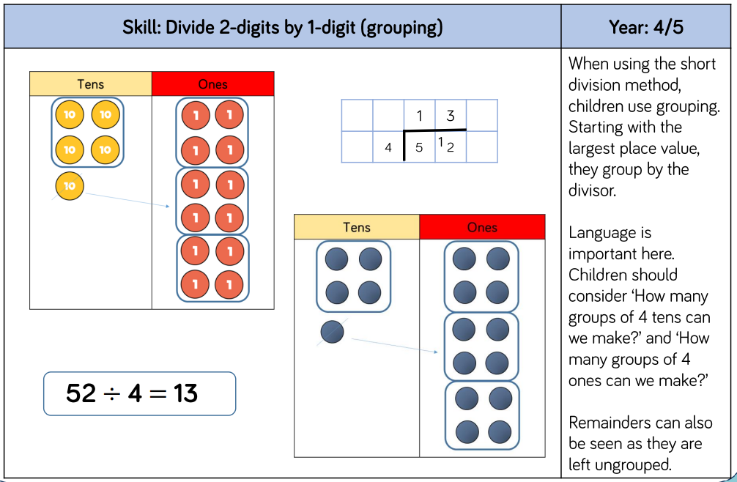
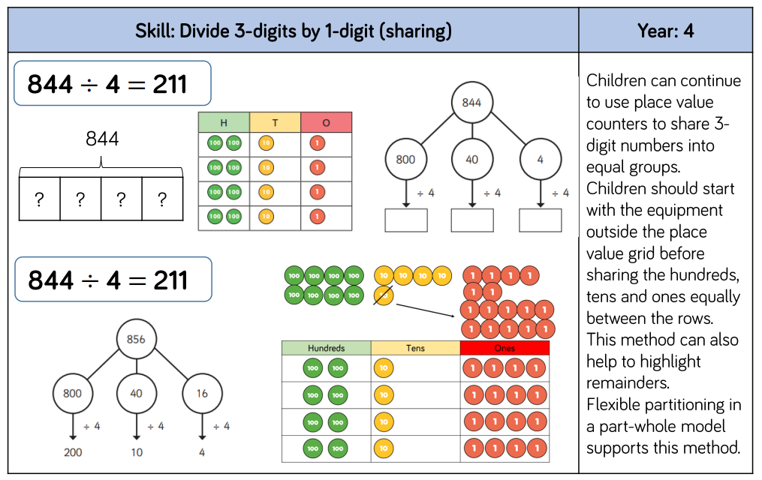

YEARS 5 AND 6

Key Resources to use: bar models, number lines, place value counters, place value grid, counting stick



