Eynesbury Church of England
Primary School
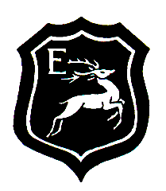
End of Year Expectations for Year 2

Dear Parent/Carer,

This booklet provides information on the end of year expectations for children in our school. The National Curriculum outlines these expectations as being the minimum requirements your child must meet by the end of this academic year.
All the objectives are worked on several times throughout the year. Any extra support you can provide in helping your children to achieve these is greatly valued.

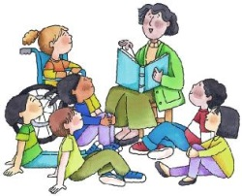
At the end of the year, in the school report, your child will be assessed at how well they have met these expectations. The terminology used for assessment is:
Below, Emerging, Developing, Secure and Mastery.
Children assessed at Secure and Mastery will have met all age related expectations.

If you have any queries regarding the content of this booklet or want support in knowing how best to help your child please talk to your child’s teacher.

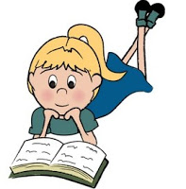
Reading
We expect children to be able to do all of
these things by the end of Year 2.

Word skills:
Read words quickly and accurately.
Read words with two or three syllables.
Read words with common word endings, such as -ing and -ed.
When meeting a word that has not read before, sound out the word without help from an adult.
Re-read my books, to become better at reading the text.
Read out their own written work with confidence and expression.

Comprehension skills:
Listen, discuss and can express thoughts about poems, stories and non-fiction books read.
Can discuss things in the order they happen and if they are connected.
Can talk about all the different stories read.
Enjoys finding out about non-fiction books and how they are set out.
Can recognise simple language patterns in stories and poems.
Can discuss the meaning of words.
Is happy to discuss favourite words and phrases from reading.
Can say out loud a number of poems that have been learnt.
Can understand the books read.
Checks what is being read makes sense.
Can say why certain things happen in a book or why a character says the things they do.
Can answer and ask questions about what I have read.
Able to guess what happens next in a story, using what has gone on before.
Can turns to discuss and listen to others.
Can explain and discuss what has happened in books that have either been read or have been read to them.
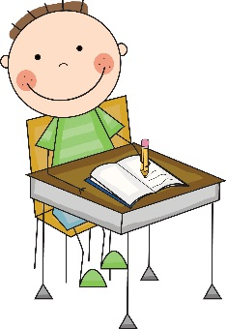
Writing
We expect children to be able to do all these things by the end of Year 2.

Spelling
Segment words into phonemes and representing these by graphemes, spelling many correctly.
Learn new ways of spelling phonemes for which one or more spellings are already known, and learn some words with each spelling, including a few common homophones.
Learn to spell common exception words.
Learn to spell more words with contracted forms.
Learning the possessive apostrophe [for example, the girl's book].
Distinguishing between homophones and near-homophones.
Add suffixes to spell longer words, including -ment, -ness, -ful, -less, -ly.
Write from memory simple sentences dictated by the teacher that include words and punctuation taught so far.

Handwriting
Write capital letters and digits of the correct size, orientation and relationship to one another and to lower case letters.
Form lower-case letters of the correct size relative to one another.
Use spacing between words that reflects the size of the letters.

Composition
Proof-read to check for errors in spelling, grammar and punctuation
Write stories about personal experiences and those of others (real and fictional).
Write about real events.
Write poetry.
Planning or saying out loud what they are going to write about.
Evaluating their writing with the teacher and other pupils.
Re-reading to check that their writing makes sense and that verbs to indicate time are used correctly and consistently, including verbs in the continuous form.
Read aloud what they have written with appropriate intonation to make the meaning clear.

Vocabulary Grammar Punctuation
Use punctuation correctly, including full stops, capital letters, exclamation marks, question marks and use commas for lists.
Use the present and past tenses correctly and consistently including the progressive form.
Use subordination (using when, if, that, or because) and co-ordination (using or, and, or but).
Learning how to use apostrophes for contracted forms and the possessive.
Use expanded noun phrases to describe and specify [for example, the blue butterfly].
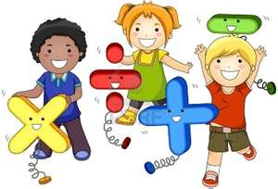
Maths
We expect children to be able to do all these things by the end of Year 2.
- Read and write numbers up to 100 in numerals and in words
- Compare and order whole numbers up to 100
- Count from zero in multiples of 2, 3 and 5
- Count in tens from any number, forwards and backwards
- Know addition and subtraction facts to 20
- Add and subtract numbers including a two-digit number and ones, a two-digit number and tens, two two-digit numbers, and three one-digit numbers
- Know that zero is a placeholder
- Know the meaning of odd and even numbers
- Know doubles and halves up to 20
- Know multiplication facts for the 2, 5 and 10 multiplication tables
- Know division facts related to the 2, 5 and 10 multiplication tables
- Derive addition and subtraction facts to 100 using known facts to 20
- Recognise and name the fractions ¹/₃, ¹/₄, ²/₄, ³/₄
- Find equivalent fractions such as ½ is the same as 2/4
- Find a fraction of an amount, length or number
- Know the symbols =, <, >, ×, ÷
- Know the symbols for pounds (£) and pence (p)
- Solve problems involving money inc. finding a total and giving change.
- Tell the time to the nearest five minutes using an analogue clock, including ‘quarter past’ and ‘quarter to’.
- Know that 60 minutes = 1 hour
- Know that 24 hours = 1 day
- Know the standard units for length (m, cm), mass (kg, g), temperature (°C) and capacity (litres/ml)
- Use a ruler to measure lengths in millimetres and centimetres
- Use mathematical vocabulary to describe position, direction and movement
- Interpret and construct pictograms, tally charts and block diagrams
- Know the names and number of sides of 2D shapes
- Know the names and number of faces of 3D shapes
- Known the meaning of ‘edges’, ‘faces’ and ‘vertices’

