Accessing e-books – Parent Guide

- Go onto the website: www.oxfordowl.co.uk
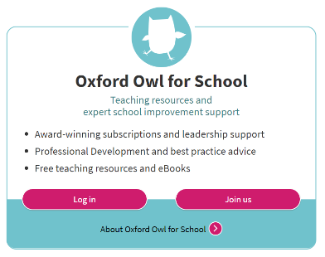

- Select ‘Oxford Owl for School’ and click ‘log in’

- Click on the ‘students’ tab and enter your child’s
details from their sign in card.

- Select ‘homework’ to access an assigned e-book. A new e-book should be assigned to your child every Friday. This will contain the sounds taught that week.

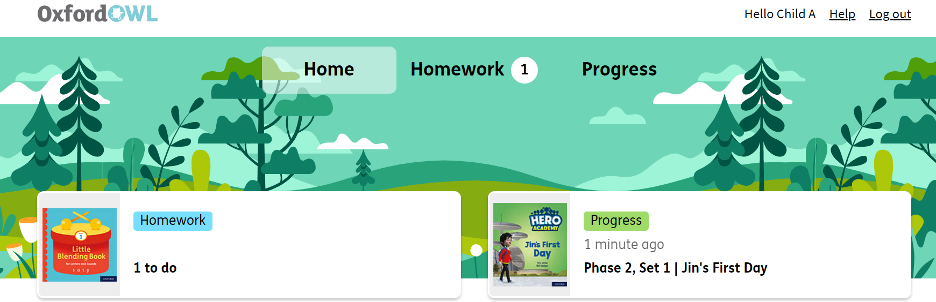

You can also access the books from the ‘e-book Library for Letters and Sounds – My Bookshelf’
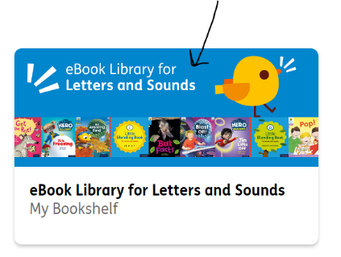

- Please encourage your child to read this text four times to build their fluency and confidence across the week. Spending 10 minutes a day reading with your child will hugely support them in their journey to becoming an independent reader.

- Once your child has read the book four times, click ‘finished book’ and encourage your child to self-evaluate and decide how they felt about the book.

- Click ‘done’

