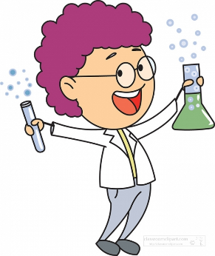

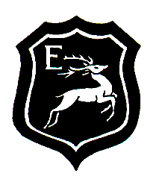
An Eynesbury Scientist will know about some famous scientists, such as:

- Marie Curie – Physicist and Chemist
- Galileo Galilei – Physicist
- Charles Darwin – Biologist
- Isaac Newton – Physicist
- Albert Einstein – Physicist
- Rosalind Franklin – Chemist

An Eynesbury Scientist in Upper Key Stage 2:
- Can name 5+ of the 3 types of variable.
- Can construct questions from chosen variables.
- Can identify variables from questions.
- Can justify a prediction.
- Can list equipment needed to carry out an investigation.
- Can write a method for an investigation.
- Can identify risks and mitigation procedures associated with an investigation.
- Can produce a full plan for an investigation.
Just some of the Scientific jobs we could aspire to:
- Astonomers
- Astronauts
- Cosmologists
- Geologists
- Palaeontologist
- Ecologists
- Sports Scientists
- Botanists
- Marine Biologists
- Geneticists
An Eynesbury Scientist in Key Stage 1:
- Asks simple questions
- Suggests different ways of answering questions
- Makes observations using simple language
- Uses key vocabulary
- Notices patterns and relationships
- Explains what they have observed
- Makes simple connections to the real world
- Makes simple predictions

An Eynesbury Scientist in Lower Key Stage 2:
- Can identify up to three types of variable.
- Can identify independent and dependent variables
- Can identify control variables
- Can construct questions from chosen variables
- Can identify variables from questions
- Can make and justify predictions
- Can plan an experiment to prove/disprove a prediction
- Can identify the equipment needed to carry out an investigation
- Can write a method for an investigation
- Can identify risks and mitigation procedures associated with an investigation
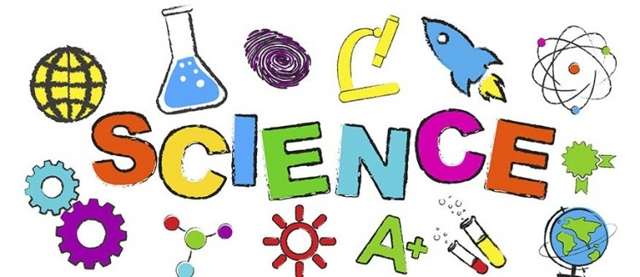
What makes an
Eynesbury Scientist?


